Ordering Decimal Numbers

- A pack of tennis balls is $1.99, bottle of water is $1.10, sandwich is $1.58 and racket is $1.40 to rent.
.
.
.
.
Put the prices in order starting with MOST EXPENSIVE

- A mars is $1.35, a twix is $1.40, a snickers is $1.38 and a galaxy is $1.45.
.
.
.
.
Put the prices in order starting with the CHEAPEST
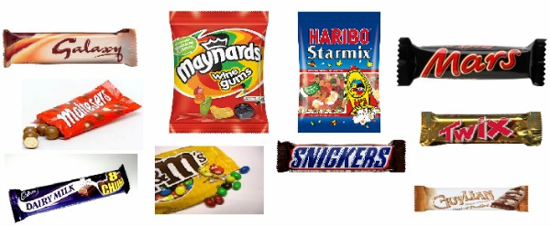
- Anneth needs to buy the biggest turkey she can to make Christmas dinner. There are only four turkeys left in the supermarket. They weigh 8.587kg, 8.59kg, 8.519kg and 8.578kg.
Circle the weight of the turkey Anneth should buy.

- Cynthia, Fiona, Rosie and Andrea went bowling. The average speed of their bowls was 14.56km/h, 17.57km/h, 16.942km/h and 17.565km/h respectively. Rank them in order from the speediest bowler first to the slowest bowler.

- Five boys took part in a long jump competition. The distance that Jimmy jumped was 4.31m, George 4.08m, Lee 4.1m, William 4.093m and Grant jumped 4.51m. Put the distance that the boys jumped in order, starting with the shortest.

